Setting up Github MCP server using Intellij

cloned the project https://github.com/executeautomation/mcp-database-server.git
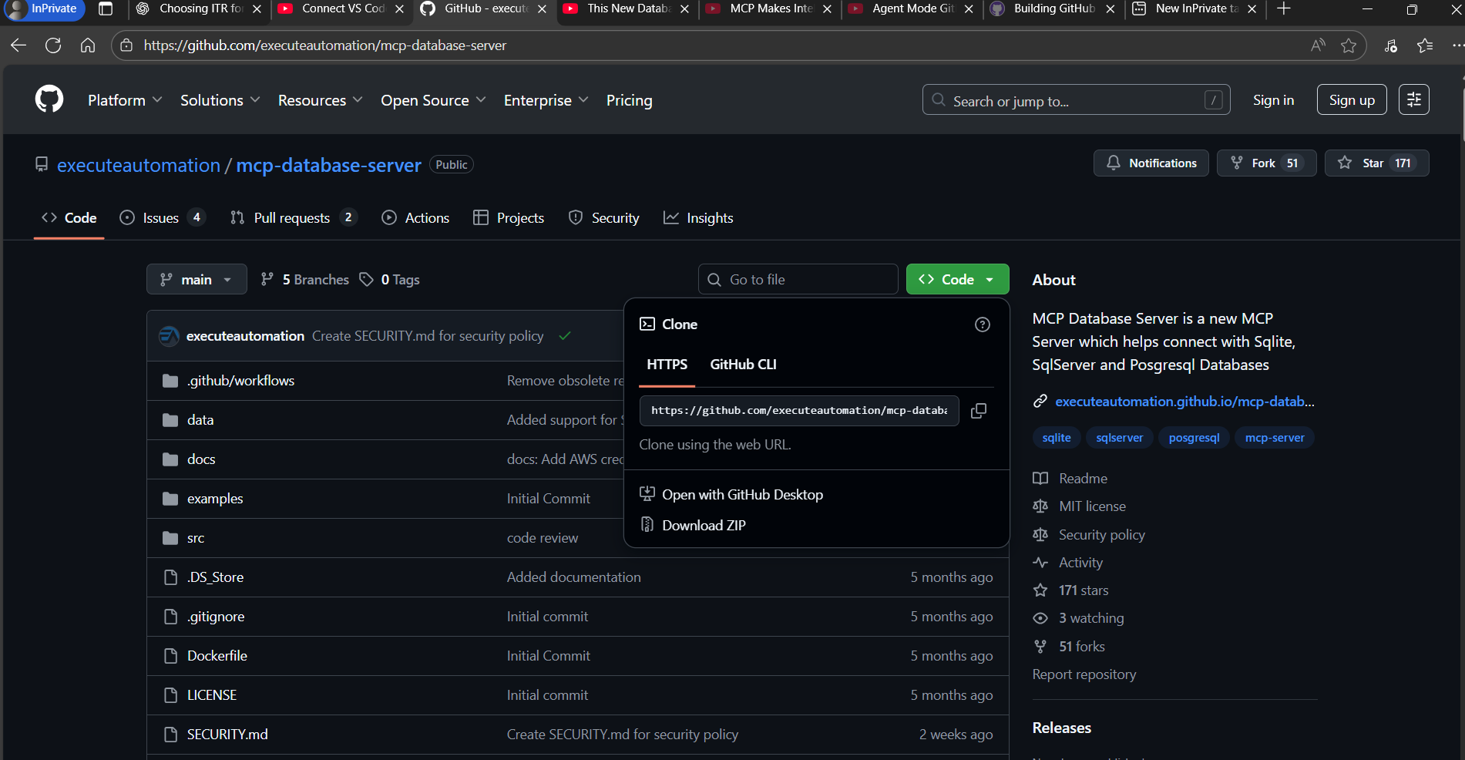

install node js latest verison
run npm install

run the command node ./dist/src/index.js --my-sql --host localhost database mcp_server --port 3306 --user root --password root

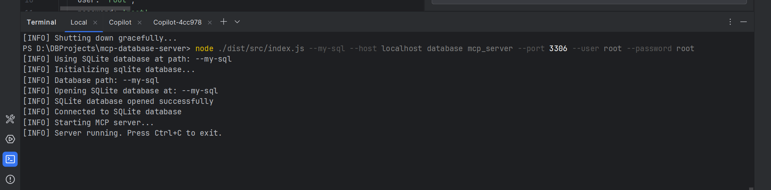
mcp server starts
also have the mysql cli installed to have the queries run on node

if not co-pilot creates script files for every prompt or use case given to it on demand on the go
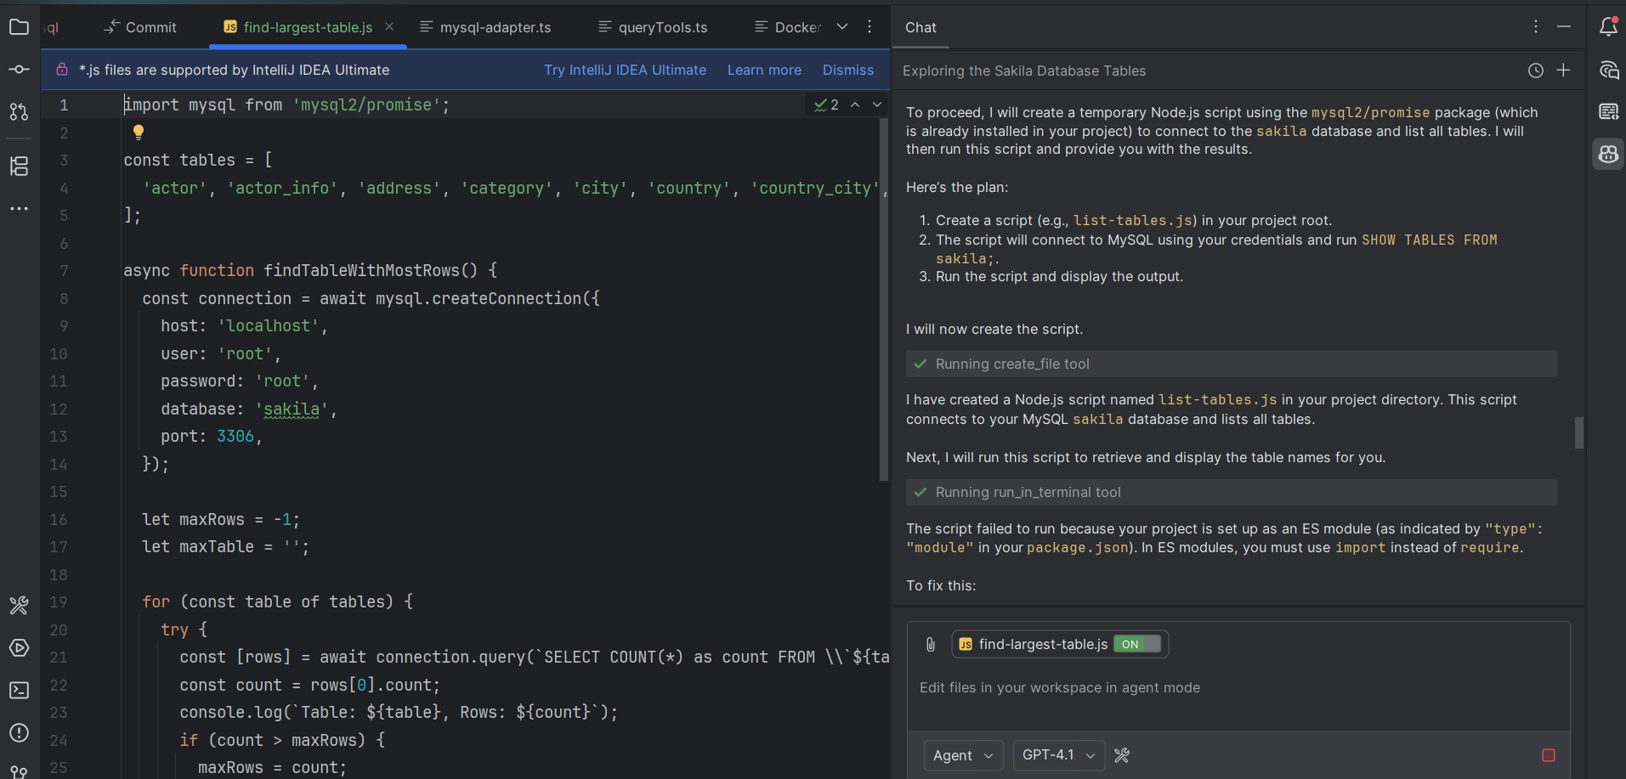
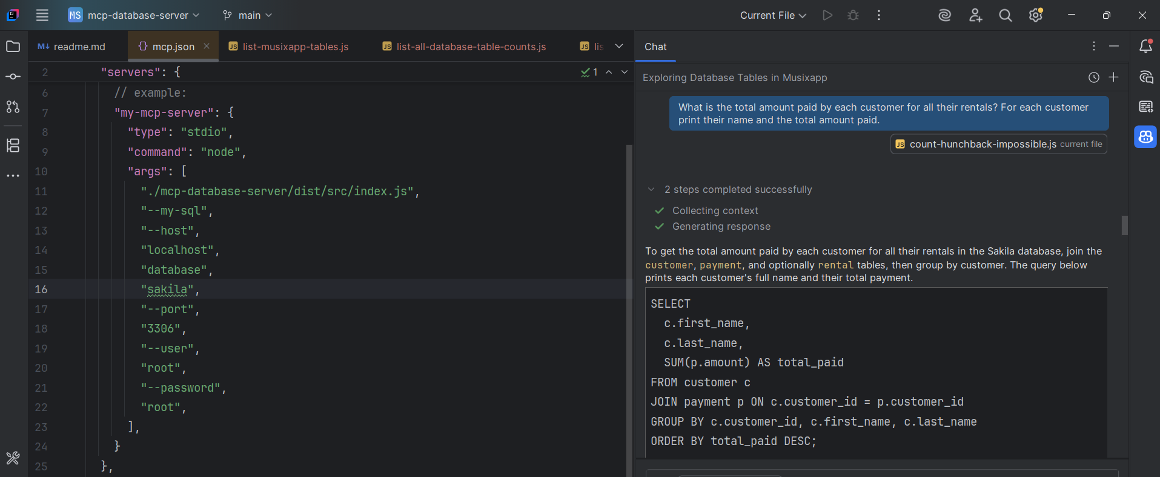
executed mujltiple queries in copilot and reached the monthly quota
